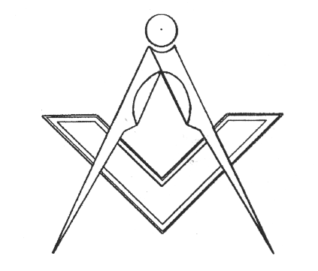
APPLICATION FOR JOINING/ AFFILIATION OF A MASONIC LODGE

IN SOUTH AUSTRALIA AND NORTHERN TERRITORY

To the Worshipful Master and Brethren of …………….. …………………………………………………. Lodge No. ………….

on the Register of the Grand Lodge of Antient, Free and Accepted Masons of South Australia and Northern Territory,

I ...................................................................................................................…………………………………………………..…
(Names in full)
being a regularly initiated, passed and raised Free and Accepted Mason hereby apply to be admitted as a Joining / Affiliating member of your Lodge.

I promise that if admitted, I will consider myself to be lawfully bound to observe the Constitution and Regulations of the Grand Lodge of South Australia and Northern Territory and the Bylaws of ………………………………………Lodge.

I declare that I have not been expelled from Freemasonry, nor am I under any sentence of exclusion or suspension from any Lodge and that all fees and monies due by me to any Lodge have been paid.

QUESTIONS TO BE ANSWERED

Residential address……………………………………………………………………………………………….…….………………………

……………….……………………………………………………………………………………………Post Code……….…………………

Postal address……………………………………………………………………………………………….…….………………………..…..

……………….……………………………………………………………………………………………Post Code……….…………………

D.O.B. ……/……./…….… Profession…………………………………Telephone No.…………………..……. Fax No.………..……...

Email address…………………..……………………………..…………………………………. Mobile No…………………………………

Name, number and constitution of lodge in which Initiated ?…………………………………………………………..............................

Name, number and constitution of
- Lodge which you are presently a member ?..............................................................................................................

- Lodge which you were last a member ?....................................................................................................................

- Have you ever made application to be a member of any other Freemasons’ Lodge ? Yes / No

If so, please give details……………..……………………………………………………………………………………………………

Was your application accepted, rejected or withdrawn ? ……………………………………………………………………………..

- Are you, or have you ever been in any way connected with any Masonic Order which is not recognized by the Grand Lodge of South Australia and Northern Territory ? Yes / No

If so, please give details ................................................................…….............................................................……..…………

- Have you ever been found guilty by a Court or other tribunal having lawful jurisdiction over you, of any criminal or civil offence?

Yes / No

If so, please give details, including any sentence applied ………….………………………………………………………………..

……………………………………………………………………………………………………………………………………………….…….

I declare that my answers to the above questions are correct in every particular.

(Applicant’s signature) …………………………………………………………………………. Dated.…….…./……../…………..
(Witnessed by a member of Freemasonry SA & NT )………………………….……………………………………………………………
We the undersigned as members of ………………………………………………………………………………..Lodge propose that
…………..…………………………………….…………………………………………………………..….be accepted as a member of
…………………………………………………………………………...… Lodge No.………
Proposer ……………………………………………………………….Seconder……………………………………………………………
Dated…………./….…./.…………

